Lab # 3
BASIC SEARCHING ALGORITHMS USING PYTHON
Objectives:
- Implement binary search, linear search and bubble sort algorithms using python.
Lab Related Theory:
Sequential Search
Sequential Search: In computer science, linear search or sequential search is a method for finding a particular value in a list that checks each element in sequence until the desired element is found or the list is exhausted. The list need not be ordered.
Code:
def Sequential_Search(dlist, item):
pos = 0
found = False
while pos < len(dlist) and not found:
if dlist[pos] == item:
found = True
else:
pos = pos + 1
return found
print(Sequential_Search([11,23,58,31,56,77,43,12,65,19],23))
Binary Search Algorithm
In computer science, a binary search or half-interval search algorithm finds the position of a target value within a sorted array. For a binary search to work, it is mandatory for the target array to be sorted. We shall learn the process of binary search with a pictorial example. The following is our sorted array and let us assume that we need to search the location of value 45 using binary search.
First, we shall determine half of the array by using this formula:
mid = low + (high - low) / 2
Here it is, 0 + (8 - 0 ) / 2 = 4 So, 4 is the mid of the array.
Now we compare the value stored at location 4, with the value being searched, i.e. 45. We find that the value at location 4 is 38, which is not a match. As the value is greater than 38 and we have a sorted array, so we also know that the target value must be in the upper portion of the array.
We change our low to mid + 1 and find the new mid value again.
low = mid + 1
mid = low + (high - low) / 2
Our new mid is 7 now. We compare the value stored at location 7 with our target value 45. The value stored at location 7 is not a match, rather it is more than what we are looking for. So, the value must be in the lower part from this location.
Hence, we calculate the mid again. This time it is 5.We compare the value stored at location 5 with our target value. We find that it is a match.
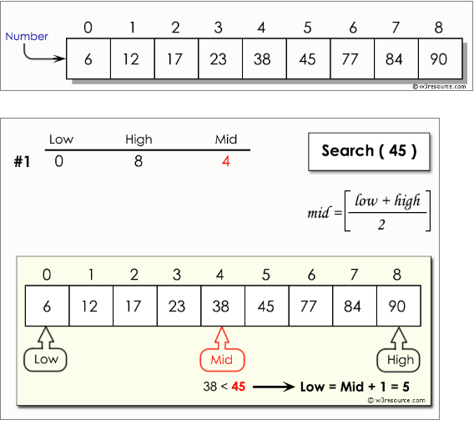

Figure 1:

Implementation of binary search algorithm

Pseudo code
The pseudo code of binary search algorithms should look like this −
Procedure binary_search
A ← sorted array
n ← size of array
x ← value to be searched
Set lowerBound = 1
Set upperBound = n
while x not found
if upperBound < lowerBound
EXIT: x does not exists.
set midPoint = lowerBound + ( upperBound - lowerBound ) / 2
if A[midPoint] < x
set lowerBound = midPoint + 1
if A[midPoint] > x
set upperBound = midPoint - 1
if A[midPoint] = x
EXIT: x found at location midPoint
end while
end procedure
Bubble sort
Bubble sort is a simple sorting algorithm. This sorting algorithm is comparison-based algorithm in which each pair of adjacent elements is compared and the elements are swapped if they are not in order. This algorithm is not suitable for large data sets as its average and worst case complexity are of Ο(n²) where n is the number of items.
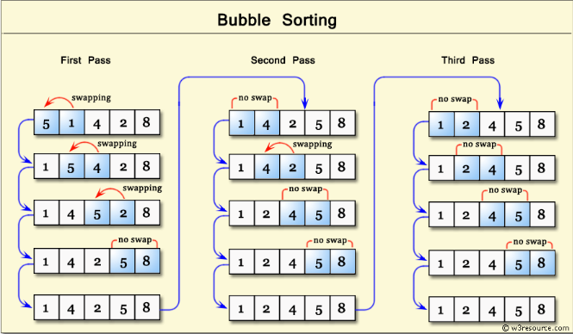

Figure 2: Implementation of binary search algorithm

Algorithm
We assume list is an array of n elements. We further assume that swapfunction swaps the values of the given array elements.
begin BubbleSort(list)
for all elements of list
if list[i] > list[i+1]
swap(list[i], list[i+1])
end if
end for
return list
end BubbleSort

LAB EXERCISE
Q1. Implement Binary Search Algorithm by Python Programming, use values of figure 1.
Q2. Implement Bubble sort Algorithm by Python Programming, Take an array of 5 elements.
Learning Outcomes:

In this lab we Implement binary search, linear search and bubble sort algorithms using python

